***SOFTWARE REQUIREMENT ANALYSIS***

**Project Name: Noteffy**

**Team Members:**

**Gaurang Tyagi (21058570017)**

**Ravish Ranjan (21058570040)**

**Rishi Mahajan (21058570043)**

**Shivang Shukla (21058570054)**

The primary function of requirement analysis is that it translates the ideas in the mind of the clients into a formal document. Thus, the output of this phase is a set of precisely specified requirements that are complete and consistent. This document is called Software Requirement Specification.

**1) Software Requirements Specification**

The following document provides complete and consistent software requirements for Noteffy, a productivity management website. The final product should provide the requirements mentioned in the following document and a formal change request will need to be raised if it requires some additional features, and a new release of this document and product will be produced.

1.1) Purpose :

Today we are so busy in our lives that we don’t pay attention to the work and tasks we were assigned or we are so procrastinating that we delay our work on and on.

To handle this our project will help you to out of this. Here you can assign yourself some task give them priorities and we will make sure that you we get it done on time. To make sure you remember your tasks we will notify you based on your task your tasks priority and never let you forget your work. You can give your tasks high priority if you got to complete the task asap or low priority for not so urgent once. We will **Noteffy** you as you like.

We also maintain a record of tasks you complete on/before the time and those you don’t to give you some social credits and we will share it with you at the end of the month for your self-analysis.

Along with this you can also maintain your normal notes when you just got to write something down or make yourself a shopping list and much more.

The objective is to build a website that meets the following criteria:

1. Quickly Accessible – The user should be able to access the website as quickly as possible.
2. Simple – The website should be simple to use for every user.

1.2) Scope :

Noteffy is a productivity management website that allows users to keep track of their productivity by allowing them to plan their days ahead of time. It also allows users to maintain notes anytime and anywhere they want.

Noteffy can be accessed anywhere and by anyone like students, teachers, clerks, software developer or casual users etc.

It can be used in colleges, schools, offices, in homes, etc.

1.3) Definitions, Acronyms, Abbreviations :

1. Definitions – none
2. Acronyms –
   1. JSON : JavaScript Object Notation
   2. HTML : Hypertext Markup Language
   3. PHP : Hypertext Preprocessor
   4. CSS : Cascading Stylesheets
3. Abbreviations – none

1.4) References :

1.) DataFlowDiagram.pptx : Data flow diagram for the project.

1.5) Overview :

The rest of the SRS includes the following:

1. Overall description of the requirements for Noteffy
2. Specific requirements for Noteffy.

**2. General Requirements**

**2.1) Product Perspective**

2.1.1) System Interfaces:

* **Noteffy is a completely self-contained software that does not belong to any larger ecosystem of products**

2.1.2) User Interfaces:

* **Users interface with Noteffy through a website:**

-New users register their details through the authentication pagedescribed in section 3.1

-Recurring users register their details through a personal dashboard page described in section 3.1

--Recurring users can view their monthly productivity charts and other statistics through a personal scoreboard page described in section 3.1

2.1.3)Hardware Interfaces

* **OS: Windows 7 / 8/ 10 , Android**
* **Monitor: At least 1280x800 pixels in 256 colours.**
* **A mouse or other pointing device & a keyboard**
* **Active internet connection**

2.1.4) Software Interfaces

* **Visual Studio Code: IDE developed by Microsoft, used for making this web-app.**
* **WAMP server: PHP based local server for hosting the web-app.**
* **JS: JavaScript (ES13) used for dynamic updation, controlling multimedia, UI and API communication. The libraries used were the standard library with JSON and fetch support and the chart API.**
* **PHP: Hypertext Preprocessor used for developing the main back-end logic. Only the standard library was used.**
* **Python: Python Programming languages used for mailing system. Libraries used will be the standard library and smtplib(for mailing).**
* **JSON: JavaScript Object Notation used for storing data.**
* **HTML5: Hypertext Markup Language used for laying the basic foundation of the UI of the web-app.**
* **CSS6: Cascading Style Sheet used for styling the elements rendered by HTML**.

2.1.5) Communication Interfaces

* **To implement the notification functionality, the mailing API in python will use the Gmail SMTP relay server through the smtplib library.**

2.1.6) Memory constraints

* **No such constraint**

2.1.7) Operations

* **There are 2 modes of operation for the user:**

**-**New users(with no cached data) interact through authentication page

-Returning users(with cached data) interact with the dashboard and create, delete and edit the notes and tasks that they make.

-Returning users also get to complete and edit to-do lists and view their monthly productivity charts.

2.1.8) Site adaptation requirements

* **No such constraint**

**2.2) Product Functions**

The functional requirements of this web-application are:-

* **Register new users.**
* **Record the Notes/Tasks created by the user.**
* **Convert a task into a to-do list over a time-bound constraint.**
* **Generate notification alert of current tasks/to-do to be completed by the user.**
* **Generate various statistical reports based on productivity of the user.**

**2.3) User characteristics**

The ideal users for the web-application are:-

* **Casual users looking to increase their productivity and have better time management**
* **Professionals seeking to better schedule their workload and keep track of it across platforms (mobile phone, workstations, etc.)**
* **Young to medium aged users who want to socially interact and positively compete with their friends, colleagues or acquaintances online on the basis of productivity**

**2.4) Constraints**

* **The product shall meet accessibility standards to make the application inclusive for all potential user groups and the developer agnosticism to make the development process robust and sustainable.**
* **The user database has to be securely encrypted to prevent data breach and violation of personal privacy.**
* **System criticality is medium level as only email id is provided by the user that can be misused but safety parameters have still been put in place**

**2.5) Assumptions and Dependencies**

* **The user database has to be securely encrypted to prevent data breach and violation of personal privacy.**
* **The application interacts with cronjob api which is only compatible with Linux operating system. For windows OS, correlating api would be task scheduler**

**2.6) Apportioning of Requirements**

* **The quirky theme has to be added to workspace and dashboard segments in order the maintain UI consistency.**
* **OTP functionality has to be reorganized to ensure user data security**
* **Graveyard and administrative panel modules have to be constructed to store expired tasks and provide control and maintenance functions.**
* **The web application is not responsive and so behaves visually as intended on desktop environments.**

**3. Specific Requirements :**

**3.1) External Interfaces**

User Interfaces

1. User Log in / Sign up

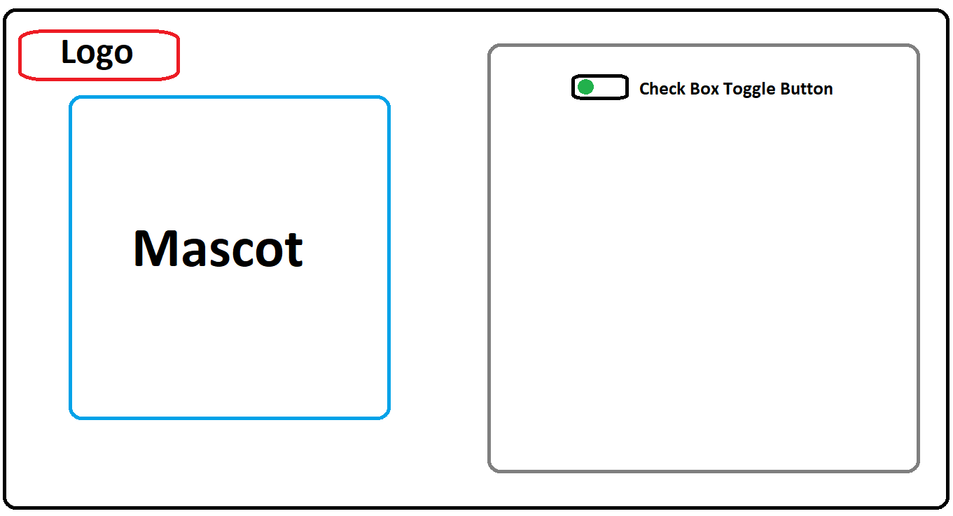

(Fig 1)

Description of each UI Button:-

* **Check Box Toggle Button: Common div in HTML to switch between Sign in & Sign up.**

*IF check Box value == 0, the div displays Sign in parameters.*

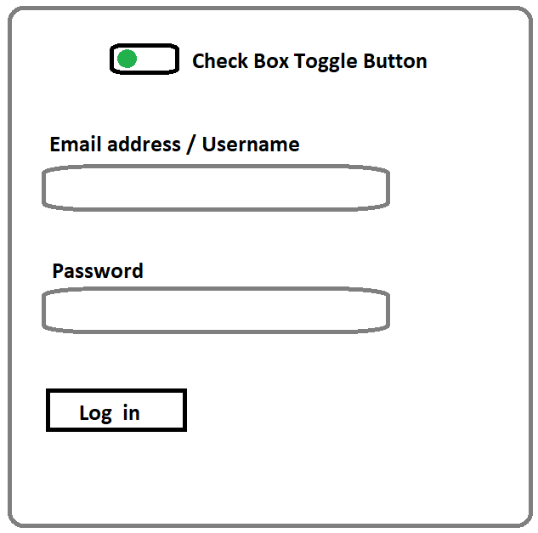Description of each UI Buttons:

* **Email address/Username: User can enter his/her registered username or email address in the input field.**
* **Password: User can enter his/her registered password in the input field.**
* **Log in: Logs the user into Noteffy.**

(Fig 2)

*IF check Box value == 1, the div displays Sign up parameters.*

Description of each UI Buttons: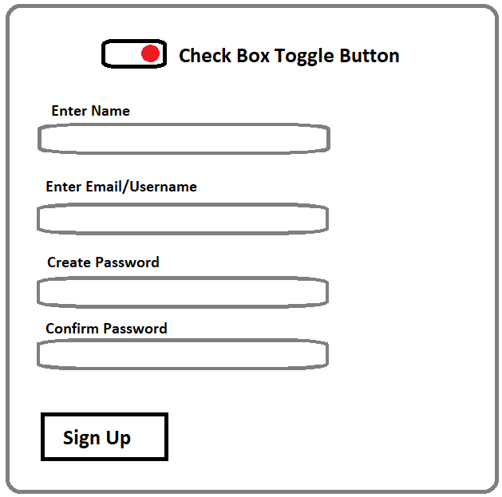

* **Email name: User can enter his/her name.**
* **Enter Email/Username: User can enter his/her email or desired username.**
* **Create Password: User can create his/her desired password.**
* **Confirm Password: Input field to confirm the desired password set by user.**
* **Sign Up: Registers the user into the database.**

(Fig 3)

2) User Workspace

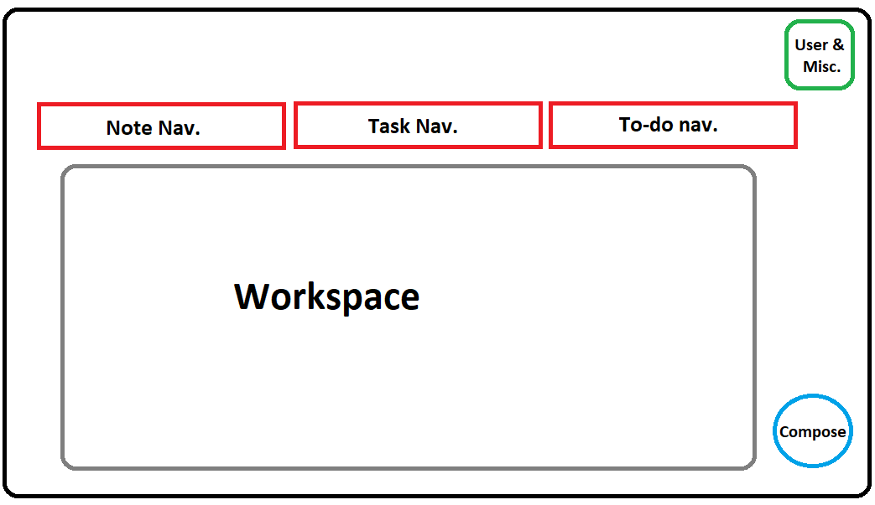

(Fig 4)

Description of each UI Buttons:-

* **Compose: To compose a new Note/Task/To-do based on current workspace selected.**
* **Note Navigation Button: To show current notes saved by user.**
* **Tasks Navigation Button: To show current tasks set by user.**
* **To-do Navigation Button: To show to-do tasks to be done by user.**
* **User & Miscellaneous- Button to display user details, Completion statistics, Settings, etc.**

1. Score Board

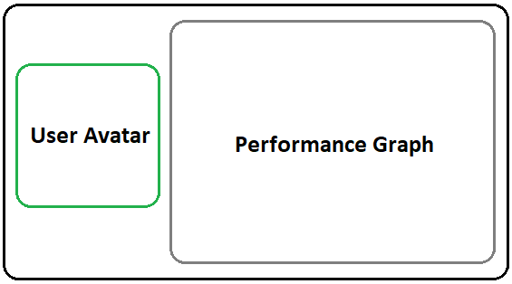

(Fig 5)

3.2) Functions:

The functional requirements of this web-application are:-

**3.2.1) Data Flow Diagram (DFD)**

**Level 0**

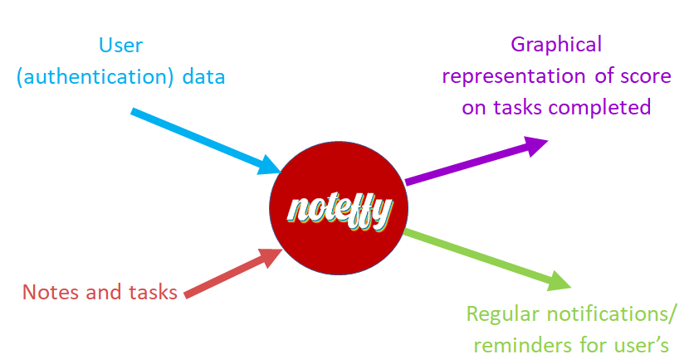

(Fig 6)

**Level 1**

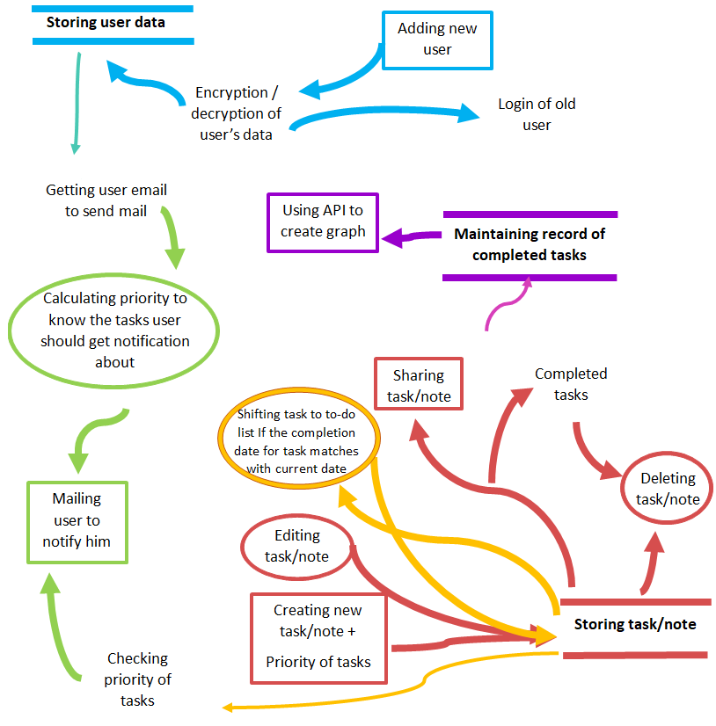

(Fig 7)

**3.2.1) Registration**

**The system shall register new users.**

**3.2.1.1) Entities**

**User Data**

**3.2.1.2) Processes**

**Registration**

**Encrypt/Decrypt**

**3.2.1.3) Topology**

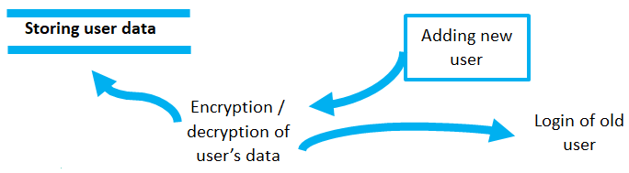

(Fig 8)

* + 1. **Note/Task Management**

**The system shall store/edit/create note/task made by the user**

**3.2.2.1) Creation Module**

**3.2.2.1.1) Entities**

**Tasks & Notes**

**3.2.2.1.2) Processes**

**Priority Setting of Tasks**

**Note/Task Storage**

**3.2.2.1.3) Topology**

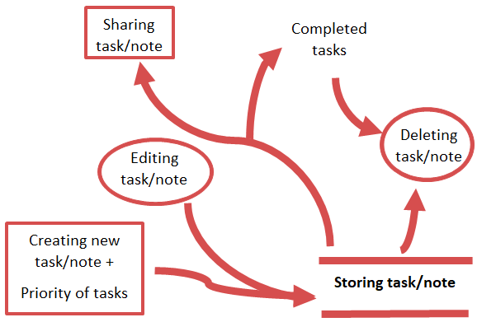

(Fig 9)

* + 1. **Maintenance of To-do list**

**The system shall convert a task into a to-do list over a time-bound constraint.**

**3.2.3.1) Entities**

**Task**

**3.2.3.2) Processes**

**Converting a task into to-do**

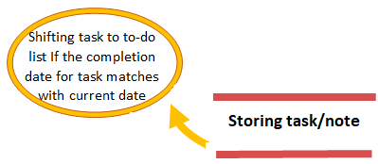

(Fig 10)

* + 1. **Notify**

**The system shall generate notification alert of current tasks/to-do to be completed by the user.**

**3.2.4.1) Entities**

**Task & To-do**

**User**

**3.2.4.2) Processes**

**Notification**

**3.2.4.3) Attributes**

**Email**

**Priority**

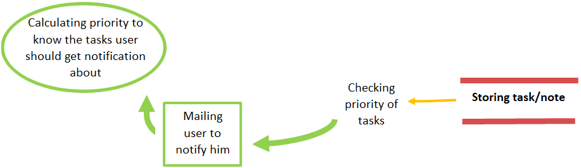

(Fig 11)

* + 1. **Performance Statistics**

**The system shall generate various statistical reports based on productivity of the user.**

**3.2.5.1) Entities**

**Tasks & To-do**

**Record**

**Graph**

**3.2.5.2) Processes**

**Graph API**

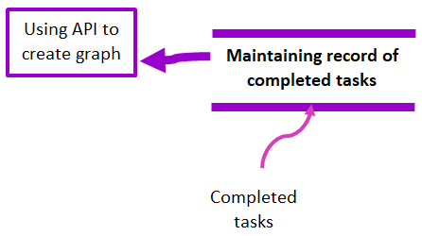

(Fig 12)

3.3) Performance Requirements :

As of now, Noteffy has not undergone through a beta-testing, hence analyzing the current performance of the prototype is a dubious task.

3.4) Logical Database Requirements :

EER (Enhanced Entity Relationship) Diagram

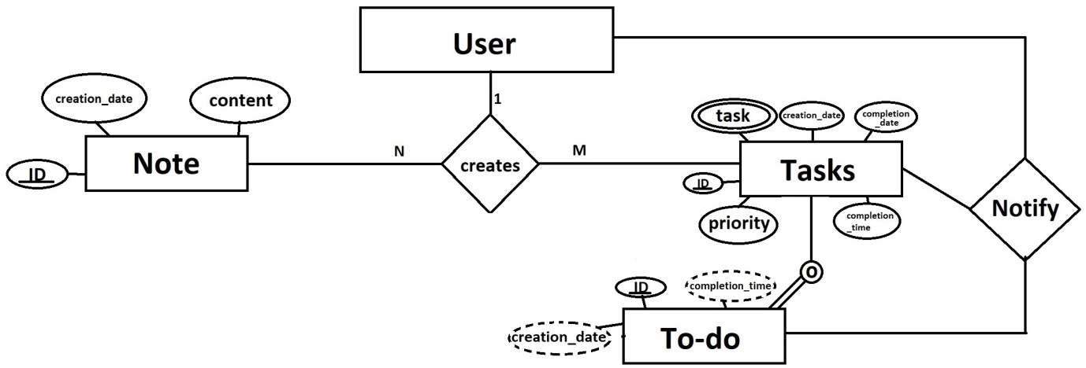

(Fig 13)

In this ER diagram, there are 4 entities: User, Note, Task & To-do.

The User entity is connected to the Note & Task entities through a "creates" relationship, which indicates that a user can create multiple notes & tasks.

The “To-do” entity is a subclass of the “Task” entity.

Task & To-do entities are connected back to the User entity through a “notify” relationship, which indicates that if a task or to-do is not completed by a completion_time fixed by user, the user will be notified.

3.5) Design Constraints :

3.5.1) Standards Compliance

* **‘Accessibility’ is an important idea behind many web standards, especially HTML. Not only does this mean allowing the web to be used by people with disabilities, but also allowing web pages to be understood by people using browsers other than the usual ones – including voice browsers that read web pages aloud to people with sight impairments, Braille browsers that translate text into Braille, hand-held browsers with very little monitor space, teletext displays, and other unusual output devices.**
* **On grounds of ‘Developer Agnostic’, Noteffy may go through several teams of designers during its lifetime, it is important that those people are able to comprehend the code & edit it easily. Complying to current Web standards, Noteffy should use open-source software for its functioning & current versions of – HTML5, CSS3, PHP8, JS ES15, Python 3.10**
* **The graphical assets used for Noteffy are designed to be perceived with a quirky theme & must be made using latest version of Adobe Photoshop CC 2022.**

3.6) Software System Attributes :

**3.6.1) Reliability**

As of now, the prototype of the web-app stores the note/task successfully created by the user through the interface. The back-end successfully notifies the user on his/her incomplete task.

On a small-scale, the reliability is well-intact.

**3.6.2) Availability**

The web-app will be available on the internet & anybody can access it via the internet.

The user data is well-intact on the server with full encryption.

In case a user is not able to complete his/her task, the incomplete task will be available in the miscellaneous tab of the web-app for the user’s reference- the user can access it any time.

If, any time in the future, the web-app is lost or gets corrupt due to obscure reasons, a backup of the app is well-kept & maintained.

**3.6.3) Security**

The user data is well-intact on the server & to avoid any case of external breach, the data is encrypted using Advanced Encryption Standard (.aes).

**3.6.4) Maintainability**

**3.6.5) Portability**

3.7) Organizing the Specific Requirements

**3.7.1) Functional Hierarchy**

**4. Change Management Process:**

**5. Document Approval:**

This SRS document shall get approved by Dr. Vandana Gandotra.

**6. Supporting Information:**

**6.1) Table of content**

***1) Introduction***

***2) General / Overall Requirements***

***3) Specific Requirements***

***4) Change Management Process***

***5) Document Approval***

***6) Supporting Information***

**6.2) Index**

***1) Introduction***

***1.1) Purpose***

***1.2) Scope***

***1.3) Definitions, Acronyms, Abbreviations***

***1.4) References***

***1.5) Overview***

***2) General / Overall Requirements***

***2.1) Product Perspective***

***2.2) Product Functions***

***2.3) User Characteristics***

***2.4) Constraints***

***2.5) Assumptions & Dependencies***

***2.6) Apportioning of Requirements***

***3) Specific Requirements***

***3.1) External Interfaces***

***3.2) Functions***

***3.3) Performance Requirements***

***3.4) Logical Database Requirements***

***3.5) Design Constraints***

***3.6) Software System Attributes***

***3.7) Organizing the Specific Requirements***

***4) Change Management Process***

***5) Document Approval***

***6) Supporting Information***

***6.1) Table of Contents***

***6.2) Index***

***6.3) Appendices***

**6.3) Appendices**

**Fig 1: User Log in/ Sign up layout**

**Fig 2: Sign in Layout**

**Fig 3: Sign Up Layout**

**Fig 4: User Workspace Layout**

**Fig 5: Scoreboard Layout**

**Fig 6: Level 0 DFD**

**Fig 7: Level 1 DFD**

**Fig 8: Registration Topology**

**Fig 9: Note/Task Topology**

**Fig 10: Maintenance Topology**

**Fig 11: Notify Topology**

**Fig 12: Performance Statistics Topology**

**Fig 13: Logical EER Diagram**